Structrual Report

# **Team Members :**

Youmna Tarek : 202001016

Toqa Radwan : 202002280

Lujain Mohamed : 202002670

Reem Amin : 202001495

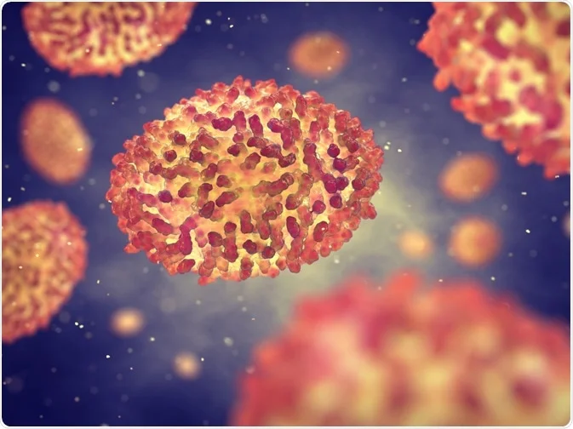Merna Medhat : 202002266

**Monkeypox virus**

Structure and life cycle :

Mpox (monkeypox) has emerged again as a global health concern. It was originally found in central Africa and could be transmitted by rodents and non-human primates. However, it has now spread worldwide. Initially, it was believed to have a high mortality rate of 3-6%, but recent evidence suggests that this was an overestimate, especially for the dominant strains. There are FDA-approved vaccines (JYNNEOS) and effective drugs (tecovirimat) available. Despite these measures, there are concerns about the possibility of another viral pandemic, which is why multiple drugs and vaccines are needed to address issues like drug/vaccine resistance and shortages. This ensures preparedness for different scenarios and reduces the impact of unpopular anti-pandemic measures that may be necessary.

The life cycle of the monkeypox virus in a human cell involves several stages that mainly occur in the cytoplasm of the host cell. After attaching to the host cell, the virus binds and merges with the cell membrane, releasing the viral core into the cytoplasm. Then, viral particles assemble into intracellular mature viruses (MV) that stay in the cytoplasm. These MVs are either released as extracellular enveloped viruses during cell lysis or acquire an additional envelope attaching to the cell membrane and eventually being released through exocytosis. Different drugs target various stages of the monkeypox virus life cycle. Cidofovir and its prodrug brincidofovir inhibit the viral DNA polymerase during DNA replication. Tecovirimat, on the other hand, targets the VP37 protein that is crucial for enveloping intracellular mature viruses with Golgi-derived membranes, forming enveloped viruses (EV). By blocking this process, tecovirimat prevents the virus from leaving infected cells, thus slowing down its spread within the body.These antiviral actions contribute to the control and treatment of monkeypox virus infections.

🡪 The replicative cycle of poxviruses such as monkeypox and smallpox : is a complex process that occurs entirely within the host cell's cytoplasm. Here is a summary and explanation of the key steps:

1. **Virion Entry & Types :**

* Poxviruses have two different types of particles: extracellular virions with double envelopes and mature virions with a single envelope.
* Extracellular virions interact with glycosaminoglycans (GAGs) on the surface of the host cell, causing the outer membrane to break and exposing the inner membrane.
* The inner membrane merges with the cell membrane, allowing the entry of the nucleocapsid core (which contains viral DNA) and lateral bodies into the cell.
* Mature virions can either directly fuse with the cell membrane or be taken in through endocytosis by binding to specific receptors on the cell surface.

1. **Uncoating and Early Gene Expression** :

* After entering the cell, the virus reveals its DNA that is covered by the core at first.
* The virus carries its own DNA-dependent RNA polymerase that produces mRNA for early proteins 🡪 ncluding those needed for uncoating.
* The short mRNA transcripts leave the capsid core and utilize the host's cytoplasmic ribosomes to create early proteins that assist in the uncoating of the viral DNA.

1. **DNA Replication & Protein Synthesis :**

* The viral DNA contains genes for DNA polymerase , leading to the replication of viral DNA and the production of multiple copies.
* Structural proteins such as core proteins and lateral body proteins 🡪 are synthesized in the cytoplasm and bind to copies of the viral DNA, forming an immature virus particle.

1. **Assembly of Mature Virion :**

* The immature virus is formed in the cytoplasm, where it combines structural proteins and RNA polymerase in the nucleocapsid core.
* Certain viral proteins merge with the Endoplasmic Reticulum (ER) & parts of the ER separate to enclose the immature virion 🡪 resulting in the mature virion.

1. **Release of Virions :**

* Mature virions are released through exocytosis.
* Cell death occurs 🡪 leading to cell lysis and the release of extracellular virions ready to infect other cells.

***Phase(1): Protein Selection***

Replication proteins :

#### DNA ligase (**6P0C**) human DNA ligase 1 bound to an Adenylated, hydroxyl terminated DNA nick in EDTA

DNA ligases catalyze the joining of DNA strands to complete DNA replication, recombination and repair transactions. To protect the integrity of the genome, DNA ligase 1 (LIG1) discriminates against DNA junctions harboring mutagenic 3’-DNA mismatches or oxidative DNA damage, but how such high-fidelity ligation is enforced is unknown. DNA ligases play a crucial role in the DNA repair process by catalyzing the formation of phosphodiester bonds between adjacent DNA fragments.

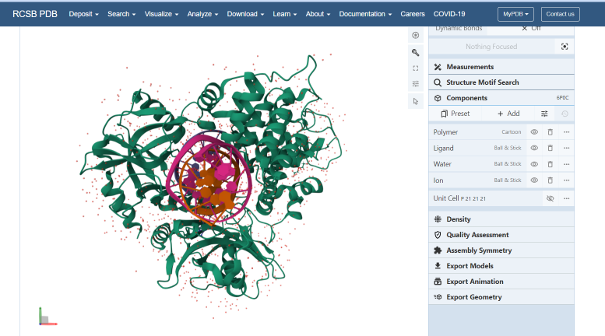

* Choosing the one 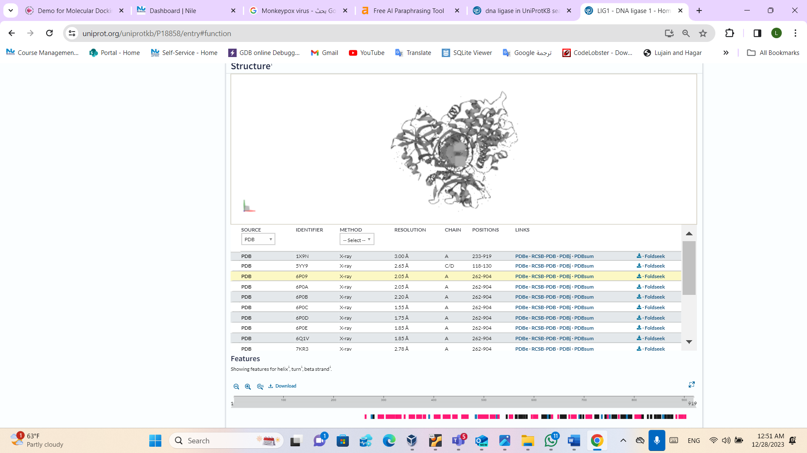with the best resolution :
* **Classification:**[**LIGASE/DNA**](https://www.rcsb.org/search?q=struct_keywords.pdbx_keywords:LIGASE/DNA)
* **Organism(s):**[Homo sapiens](https://www.rcsb.org/search?q=rcsb_entity_source_organism.taxonomy_lineage.name:Homo%20sapiens)
* **Expression System:**[Escherichia coli](https://www.rcsb.org/search?q=rcsb_entity_host_organism.ncbi_scientific_name:Escherichia%20coli)
* **Mutation(s):**No
* **Method:**X-RAY DIFFRACTION
* **Resolution:**1.55 Å
* **R-Value Free:**0.165
* **R-Value Work:**0.130
* **R-Value Observed:**0.132

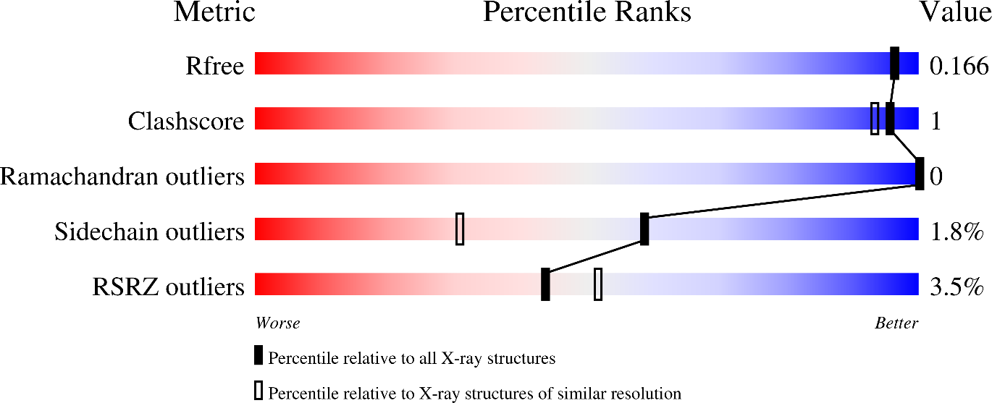**Structure Validation**

* **PubMed Abstract 🡪** DNA ligases catalyze the joining of DNA strands to complete DNA replication, recombination and repair transactions. To protect the integrity of the genome, DNA ligase 1 (LIG1) discriminates against DNA junctions harboring mutagenic 3'-DNA mismatches or oxidative DNA damage, but how such high-fidelity ligation is enforced is unknown. Here, X-ray structures and kinetic analyses of LIG1 complexes with undamaged and oxidatively damaged DNA unveil that LIG1 employs Mg 2+-reinforced DNA binding to validate DNA base pairing during the adenylyl transfer and nick-sealing ligation reaction steps. Our results support a model whereby LIG1 fidelity is governed by a high-fidelity (HiFi) interface between LIG1, Mg 2+, and the DNA substrate that tunes the enzyme to release pro-mutagenic DNA nicks. In a second tier of protection, LIG1 activity is surveilled by Aprataxin (APTX), which suppresses mutagenic and abortive ligation at sites of oxidative DNA damage.
* **It has a chain A & 3 Ligands** 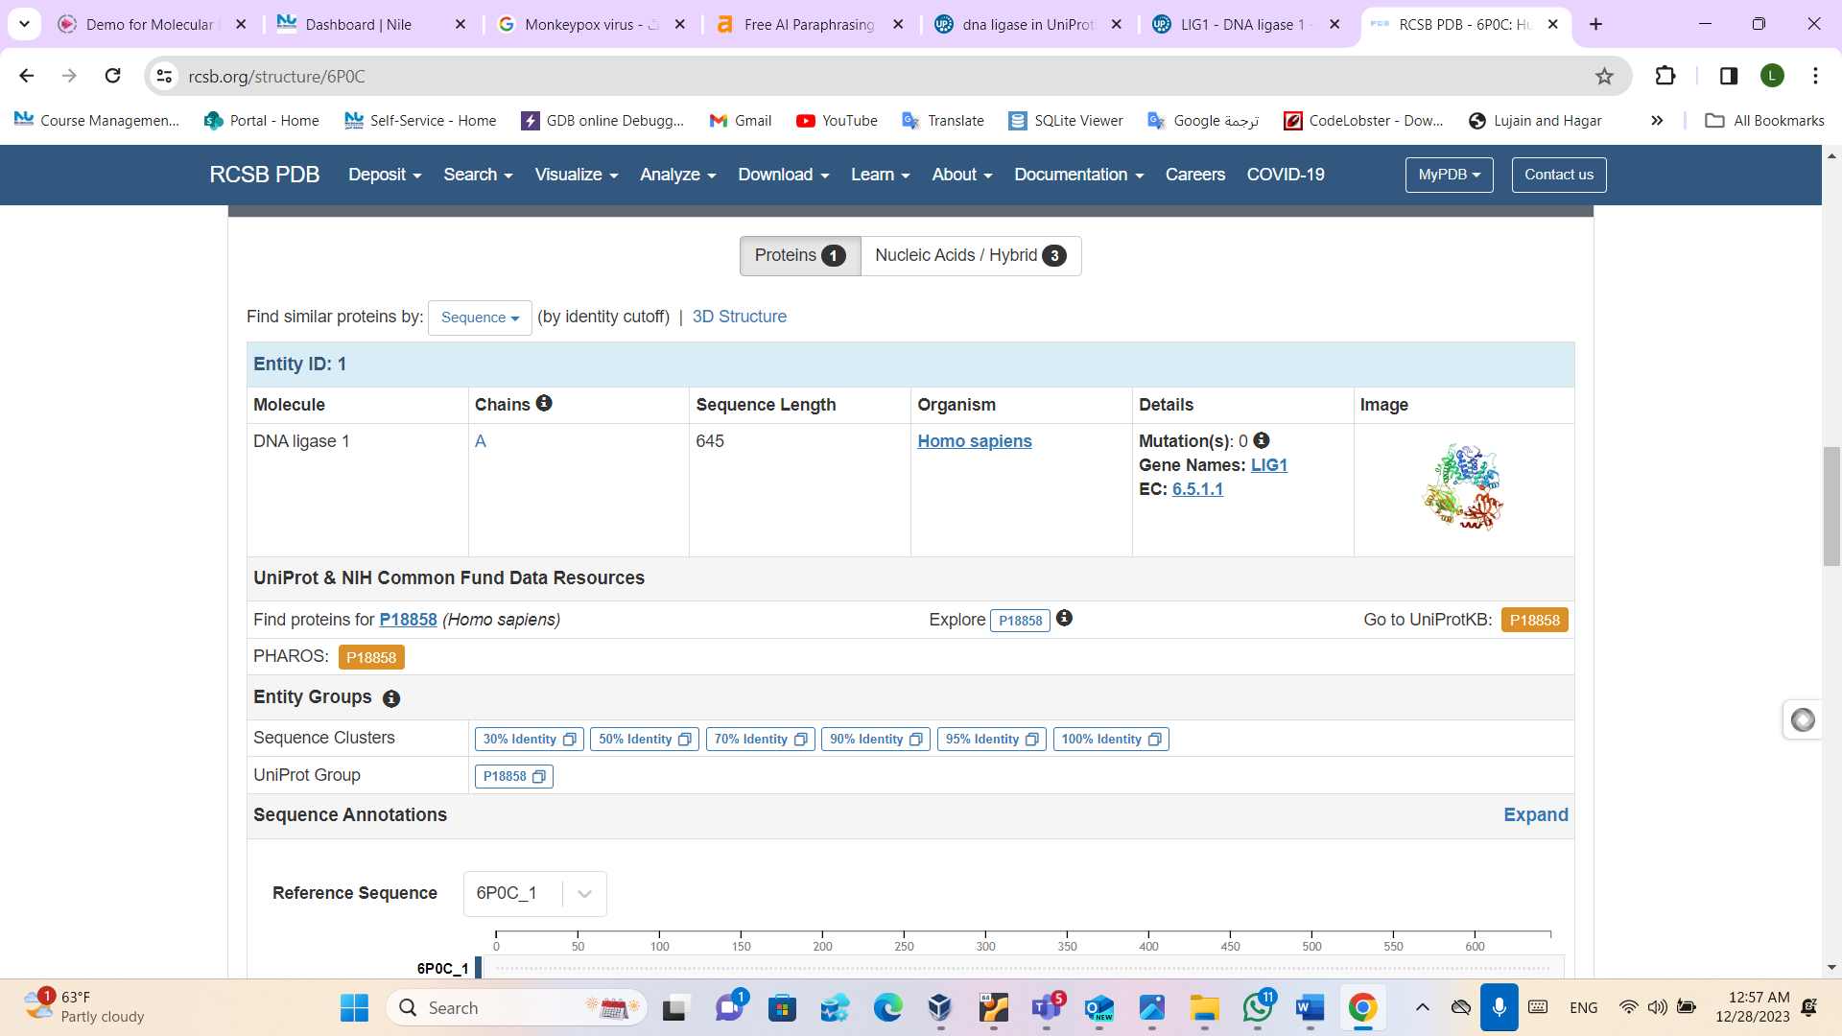

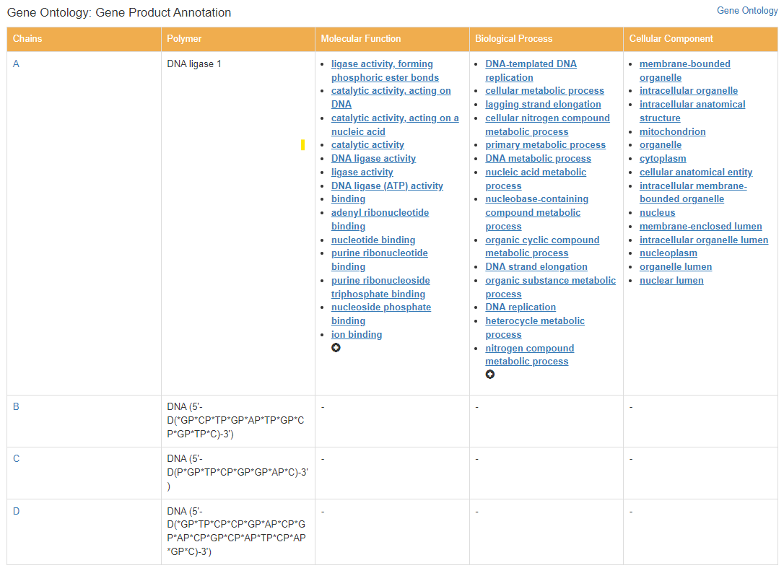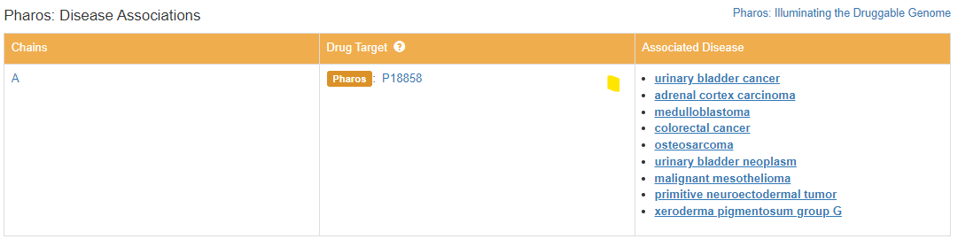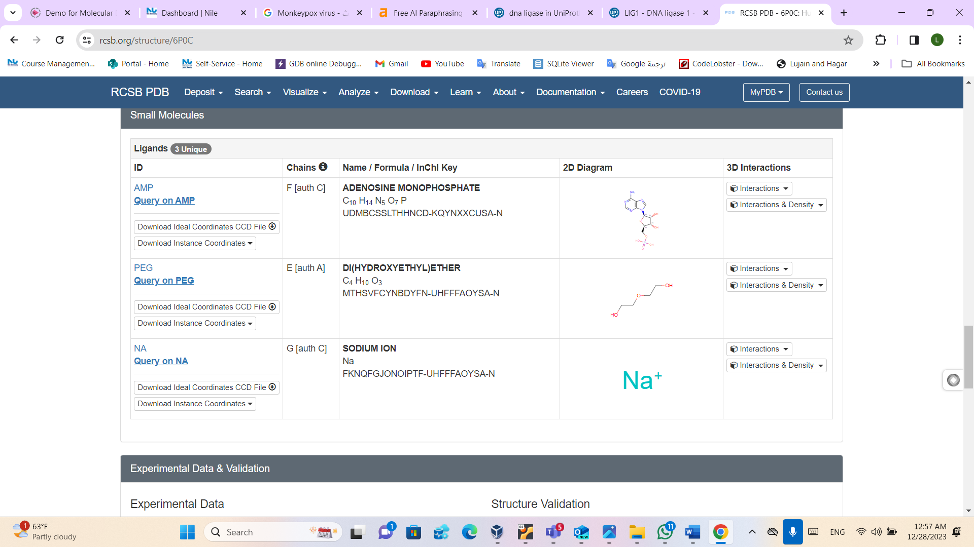

1. Viral RNA polymerase (**4N49**) Cap-specific mRNA (nucleoside-2'-O-)-methyltransferase 1 Protein in complex with m7GpppG and SAM

**Molecule_Name:** the Cap-specific mRNA (nucleoside-2'-O-)-methyltransferase 1 protein, often referred to as the mRNA cap methyltransferase, is an enzyme involved in the post-transcriptional modification of mRNA. The enzyme adds a methyl group to the 2'-O position of the first nucleotide of cellular mRNA, which is crucial for mRNA stability, processing, and evasion of the host immune response.

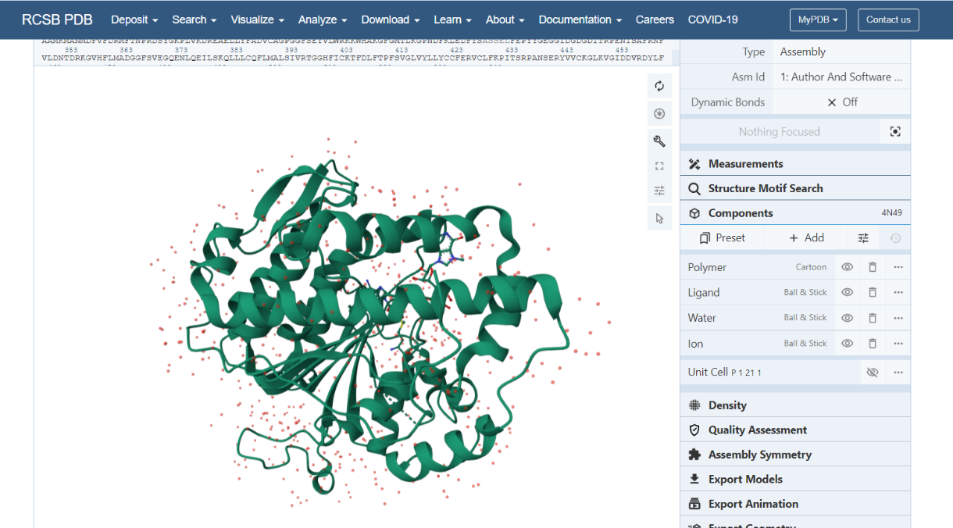

**Experimental Data Snapshot**

* **Method:**X-RAY DIFFRACTION
* **Resolution:**1.90 Å
* **R-Value Free:**0.203
* **R-Value Work:**0.154
* **R-Value Observed:**0.156
* **Chains:** chain_A
* **Sequence Length:** 428
* **Organism:** Homo sapiens
* **This protein has 3 unique ligands which are:** MGT, NA, SAM

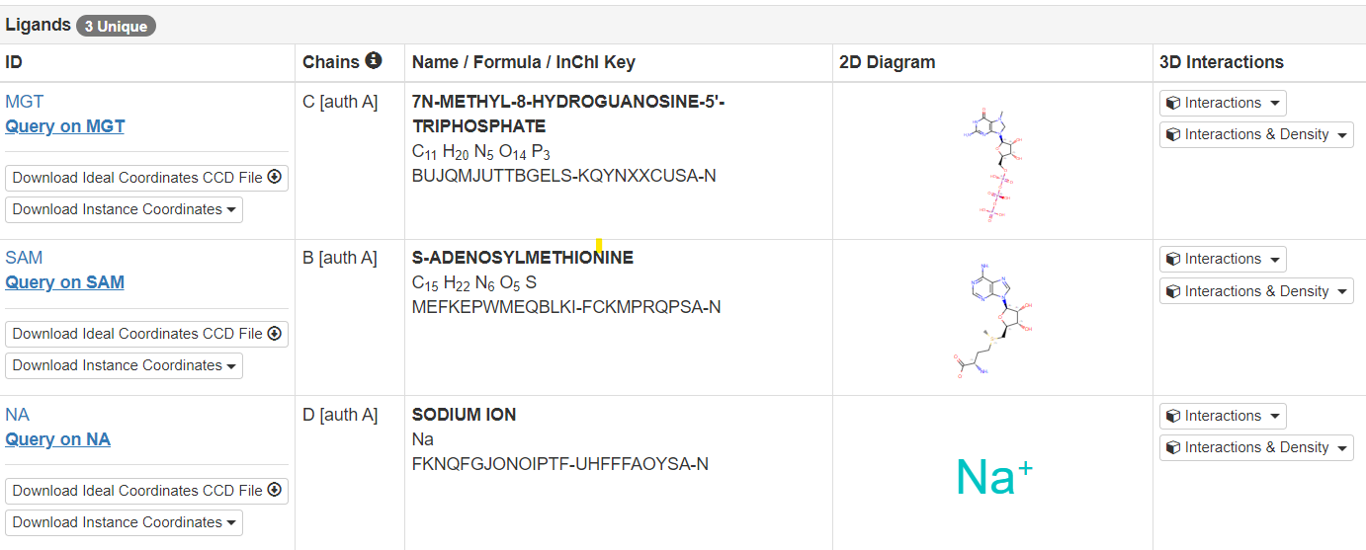

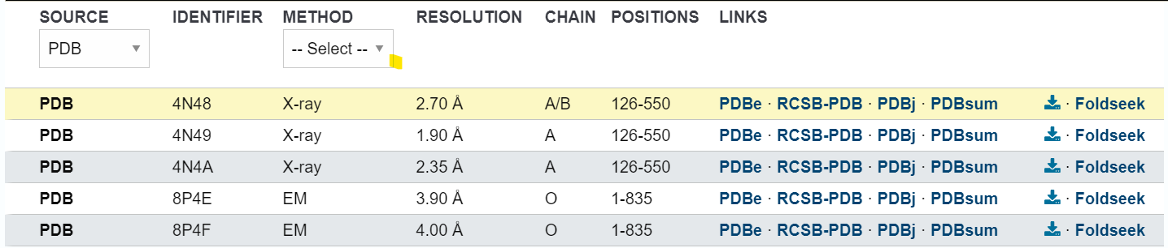

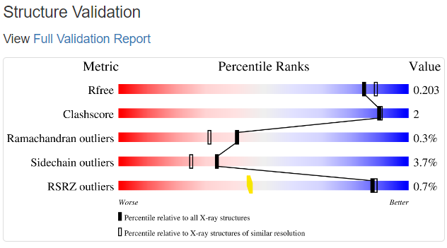

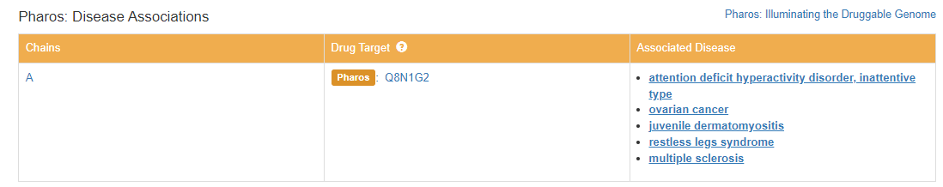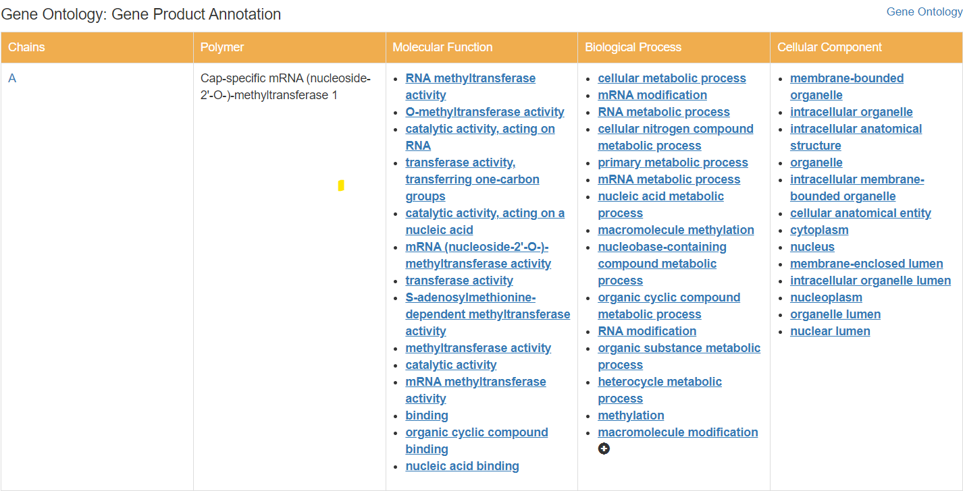

***Phase(2): Structural Modeling and Validation***

1. Homology modeling of (**O00142 · KITM_HUMAN)** :

First, We took a protein that doesn't have a 3D structure from thymidine kinase (KITM_HUMAN O00142 Thymidine kinase 2, mitochondrial) to perform homology modeling on it, first, we put its accession no. on Swiss model to build the model, then we got 50 templates and we use the best template to build our model which is the first one as shown below.

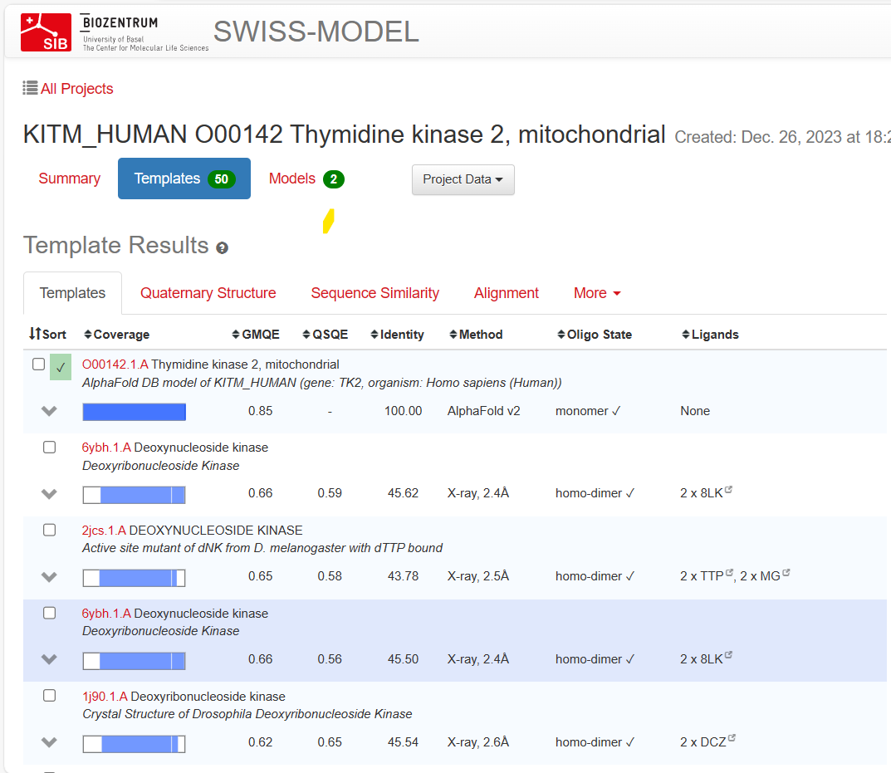

We chose the second one as the first one was 100% identical . We reviewd all templetes and we tried to choose the best one according to the resolution – it was not that much good but it was the best one.

Our choosen model has GMQE equal to 0.66 which is good as it’s close to 1, also its sequence identity is 45.62%, from its Ramachandran plot, we observe that it doesn’t have any outliers except for a few ones. so the first model is good.

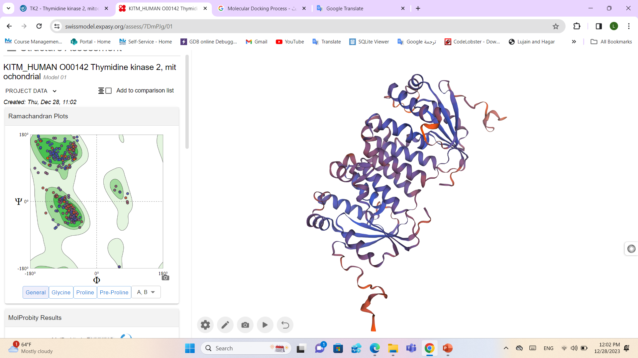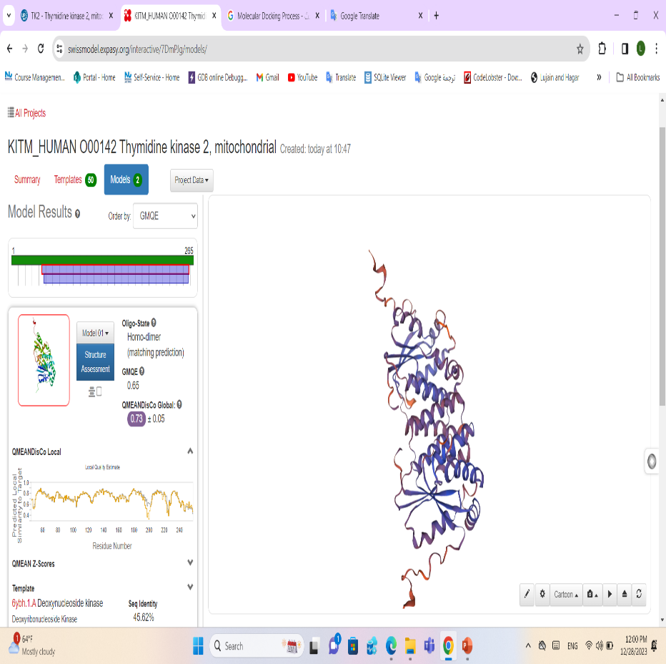

1. **Thymidine kinase (** **7QFO) Human Topoisomerase II Beta ATPase AMPPNP**

**Experimental Data Snapshot**

* **Method:**X-RAY DIFFRACTION
* **Resolution:**1.90 Å
* **R-Value Free:**0.232
* **R-Value Work:**0.193
* **Organism:** Homo sapiens
* **Chains:** chain_A
* **Sequence Length:** 400

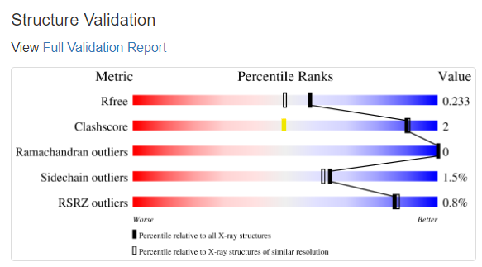

**It has 3 unique ligands**

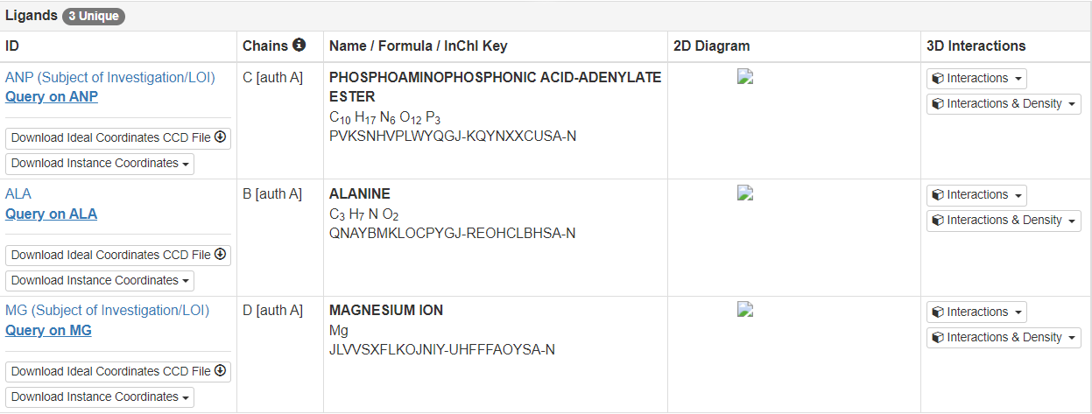

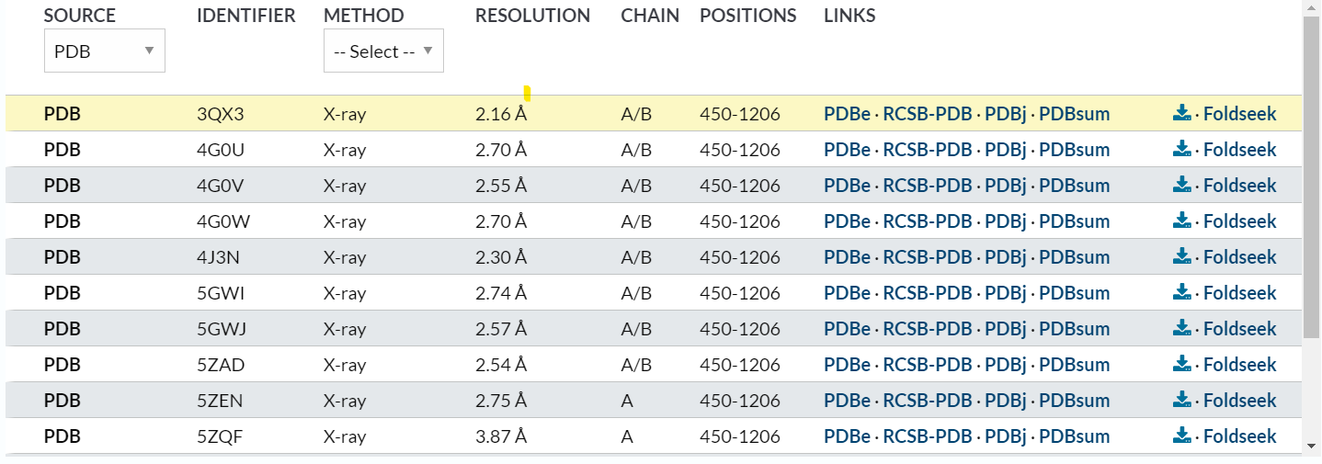

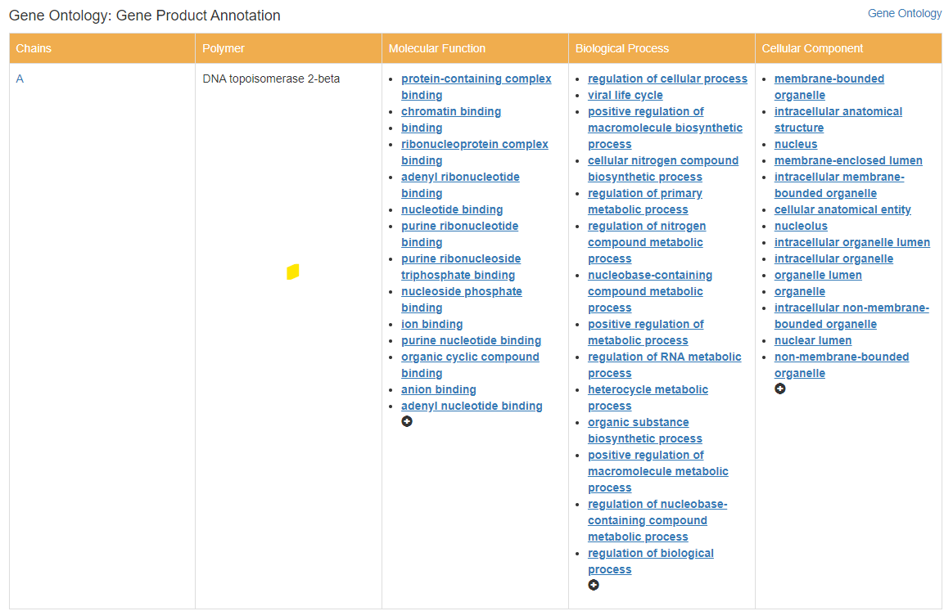

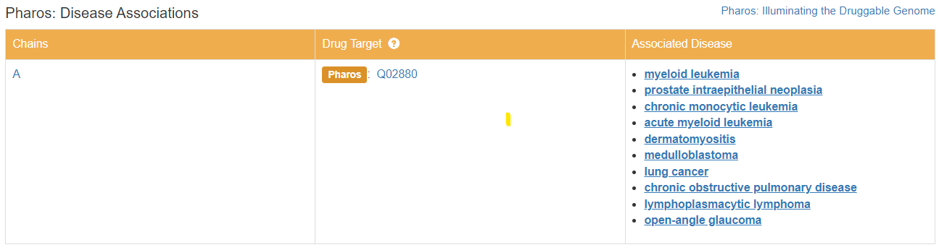

***Phase(3): Mechanistic Insights and Drug-Design:***

In this phase we did molecular docking as it plays a crucial role in predicting the preferred orientation of one molecule to another when they interact to form a stable complex. Molecular docking is particularly important for understanding the binding interactions between biological molecules, such as proteins and ligands (small molecules). It helps in predicting how these molecules interact at the atomic level.

* 1. Drug Discovery: Docking is widely used in **virtual screening** for drug discovery. It allows researchers to predict the binding modes and affinities of small molecules (potential drugs) to target proteins(which will be disscued here according to monkeybox-virus).
  2. Protein-Protein Interaction: Docking is used to study interactions between proteins. It helps in understanding the formation of protein complexes and the key residues involved in binding. This is crucial for understanding various cellular processes and signaling pathways.
  3. Structural Analysis: Docking helps in the structural analysis of biomolecular complexes, providing information about the spatial arrangement of interacting molecules and the forces involved in their binding.
* **So ,we performed the docking on the ligands of chosen replication proteins of monkey box-virus to find the best-hit and interactions between the target and the best-hit found after sorting all the docking output ( 6P0C, 4N49, 7QFO):**

**Steps of docking we’ve done:**

1. Open the target & ligand 🡪 extracted from pymol
2. Grid box using autodock vina
3. Converting pdb to pdbqt
4. Save grid_box.txt
5. Perform Virtual Screening
   1. Run the docking script that loops to give the output

$ python3 docking.py

* 1. Run the log extraction script to get the CSV (hits)

$ python3 log_extraction.py

1. Select the Best Hits after sorting

Visualize using PyMOL.

1. **Docking of 6P0C:**

# A screenshot of a computer Description automatically generated6P0C :

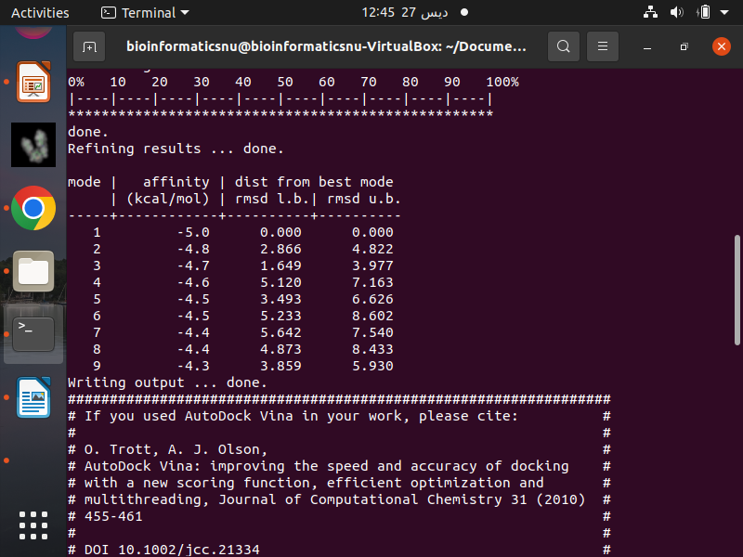

Here it’s a table of mode, affinity, dist from best mode rmsd l.b. rmsd u.b. to choose the best ligand with the best affinity after sorting them acc. to column B.

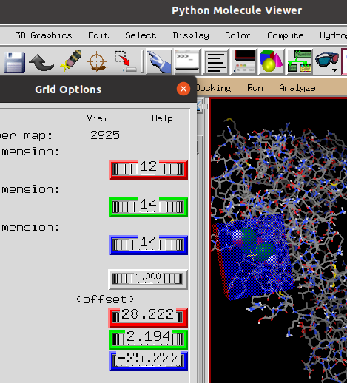

Here we do grid box and identify the parameters(X,Y,Z) to make a box around the specific region which will be used in loop of docking to identify the best affininty of ligands chosen.

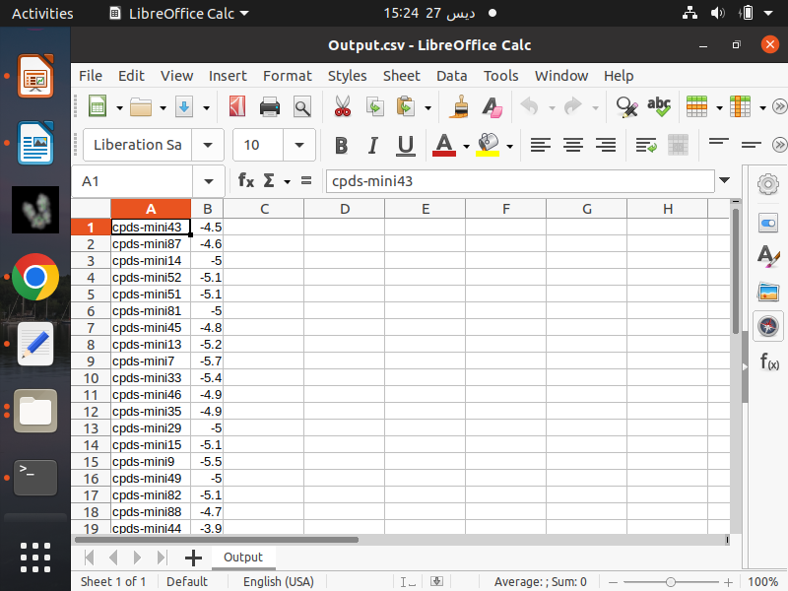

**sorting the choosen ligands acc. to column B.**

We did this step to find the distances & to identifty the interaction between them & the type of bond they connected with.

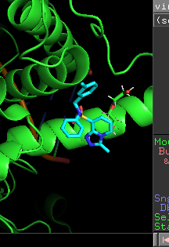

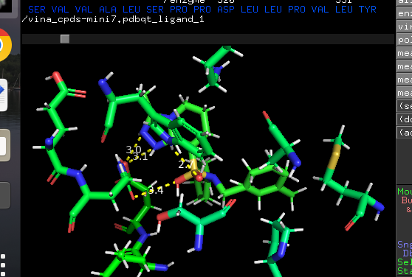

Here as shown the measured distances are: 3.1,3.0,2.7,3.4

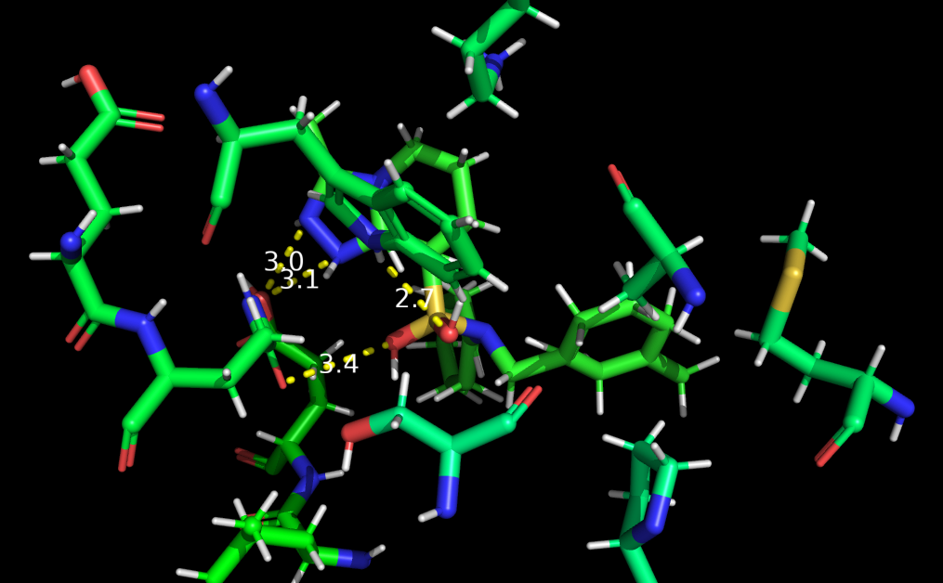

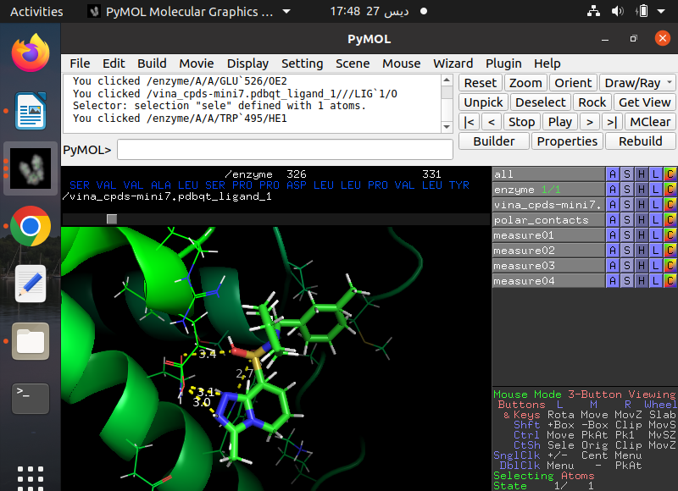

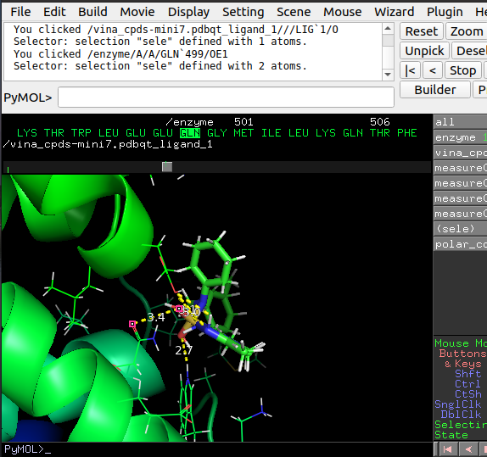

Here it shows the distance between residue and glutamin.

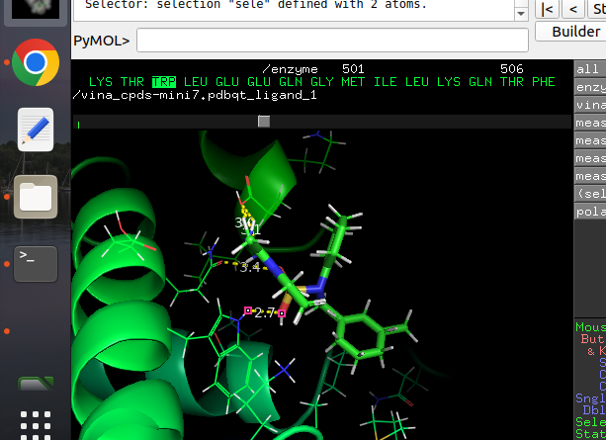

Here it shows the distance between residue and trptophan.

___________________________________________________________

* **7QFO : After doing the same steps in docking :**

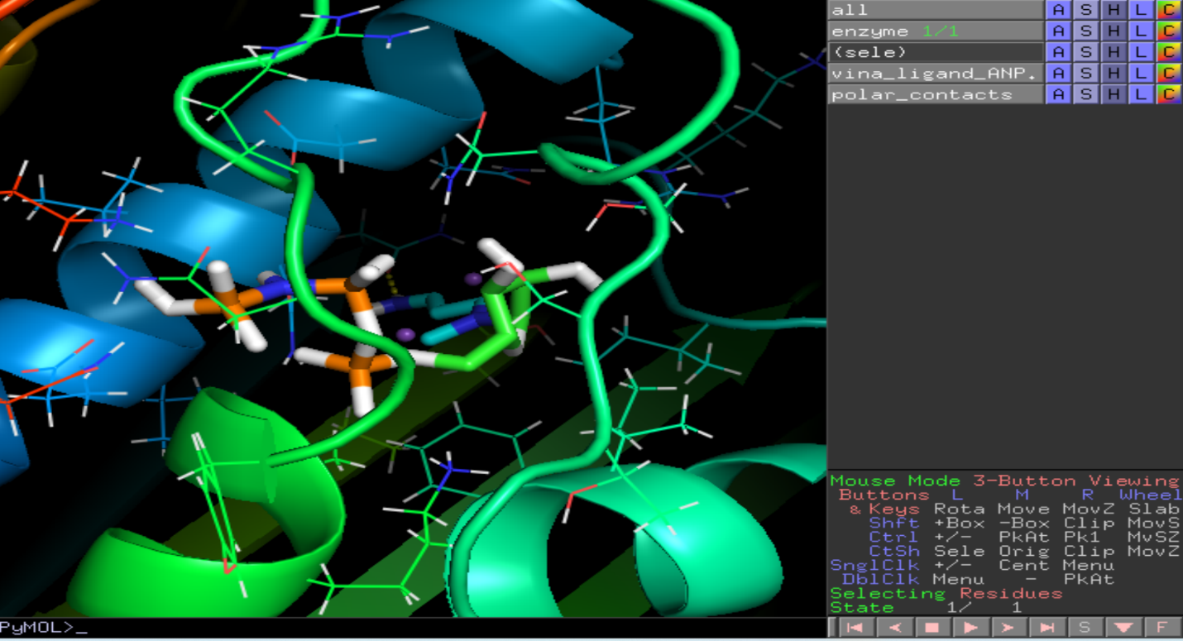

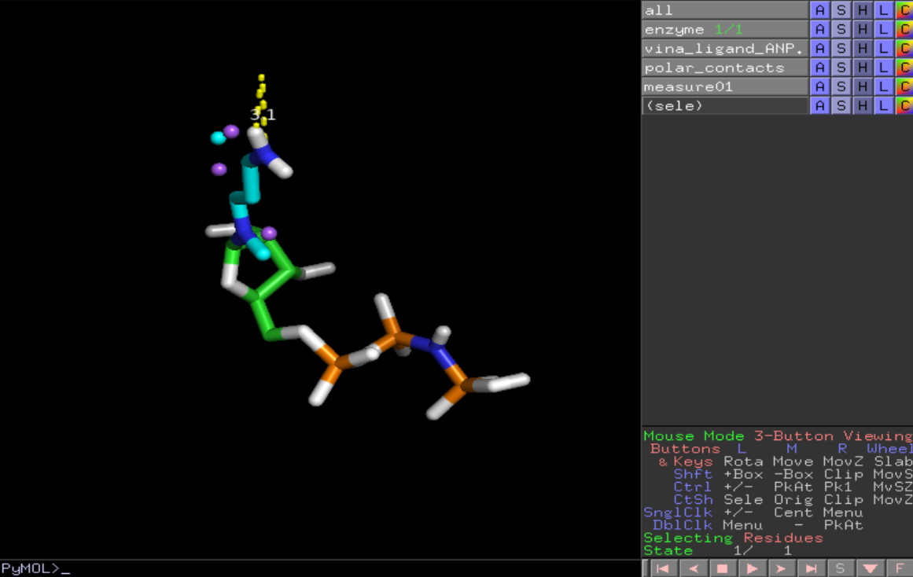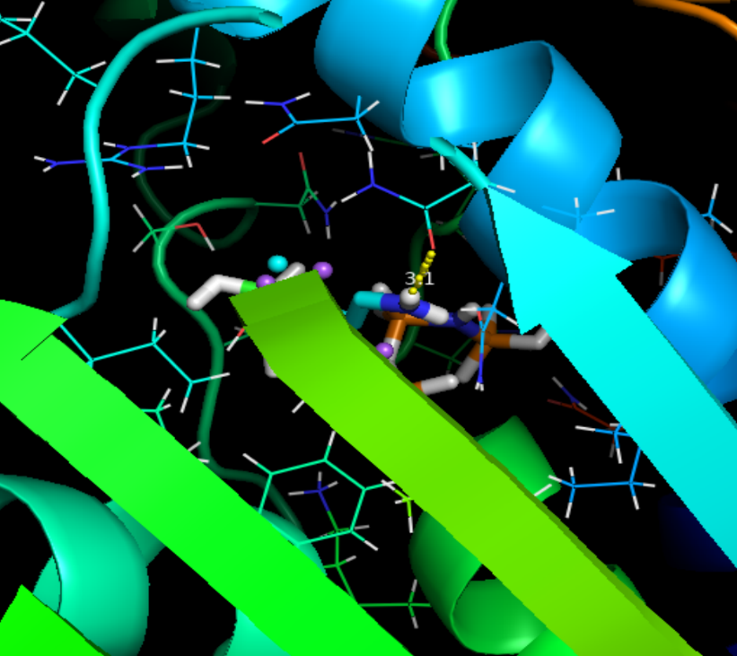**________________________________________________**

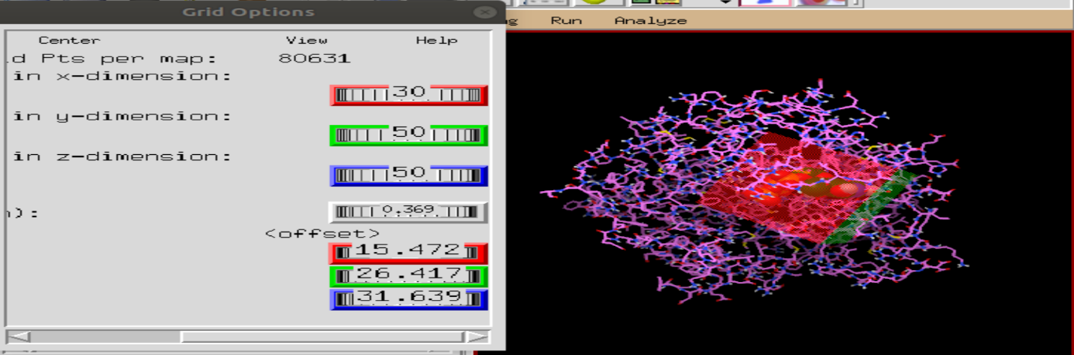**4N49 : The same as the steps we mentioned before**

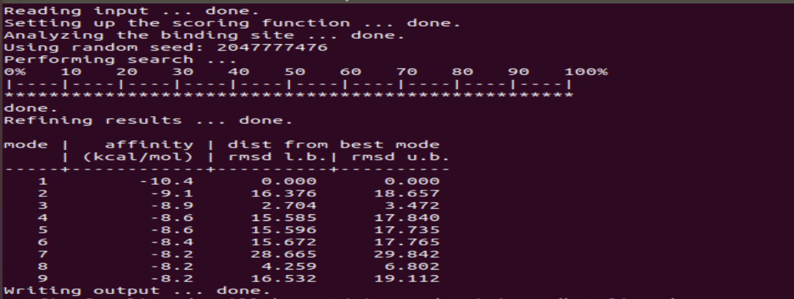

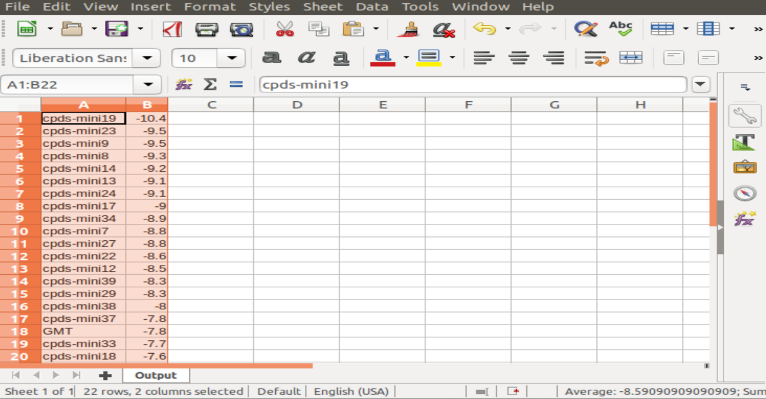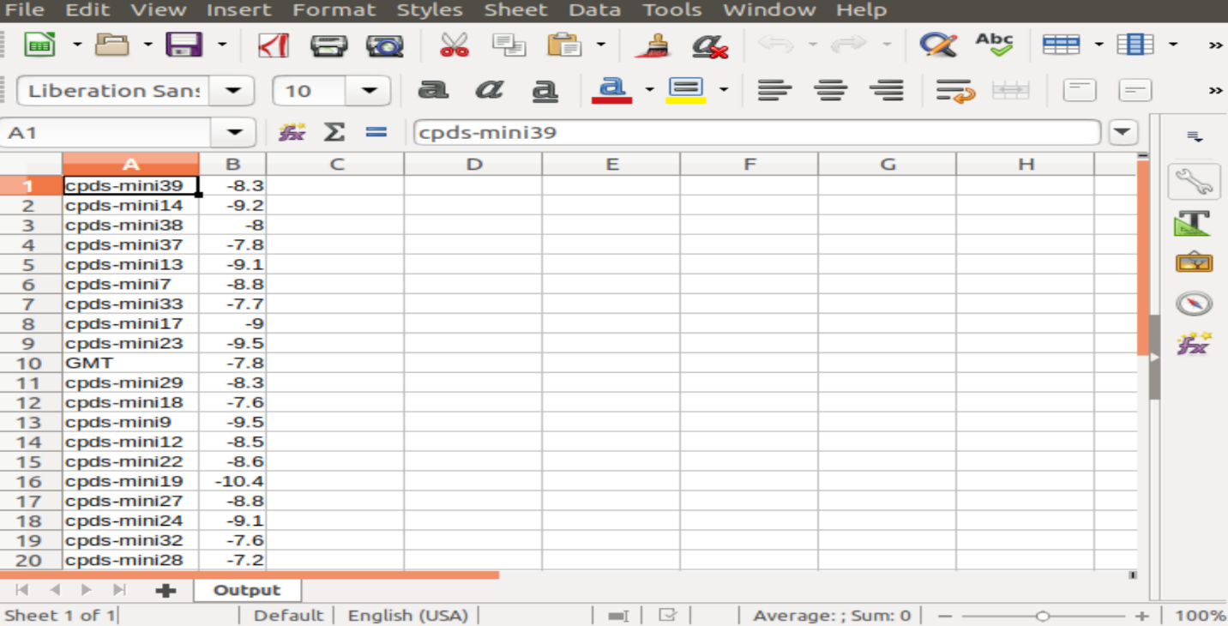

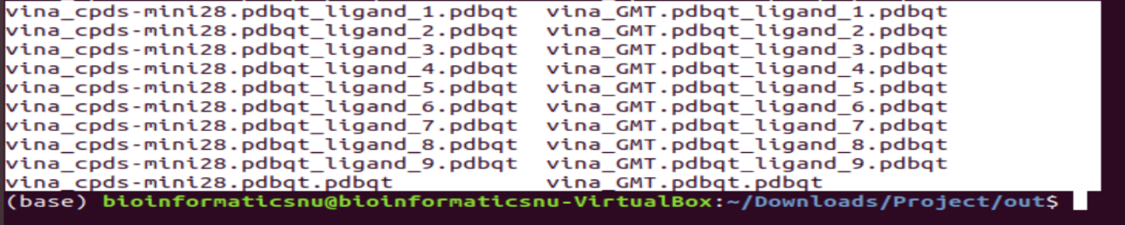

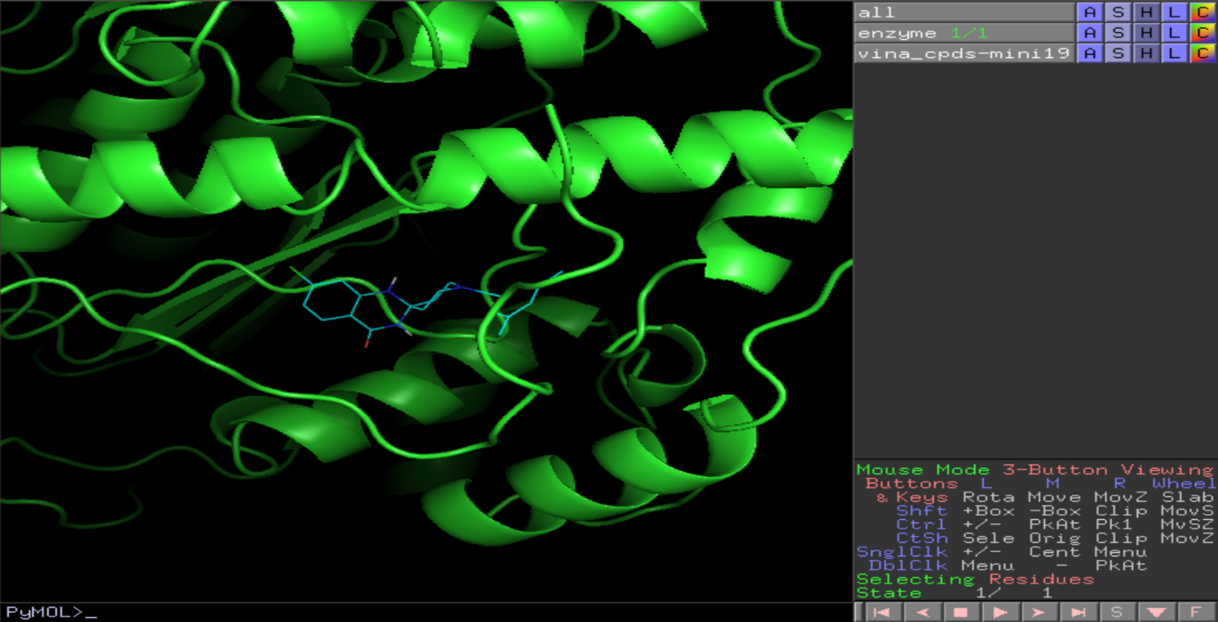

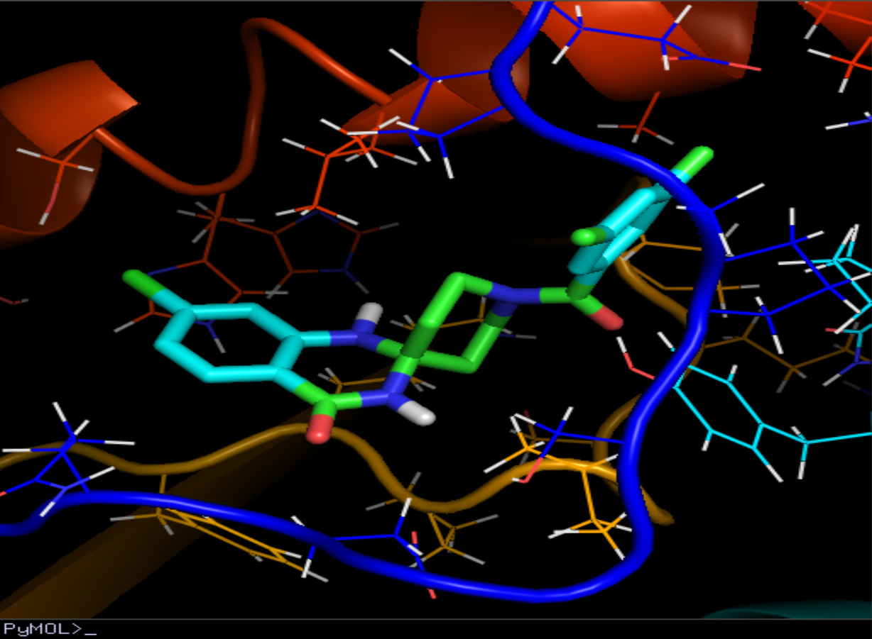

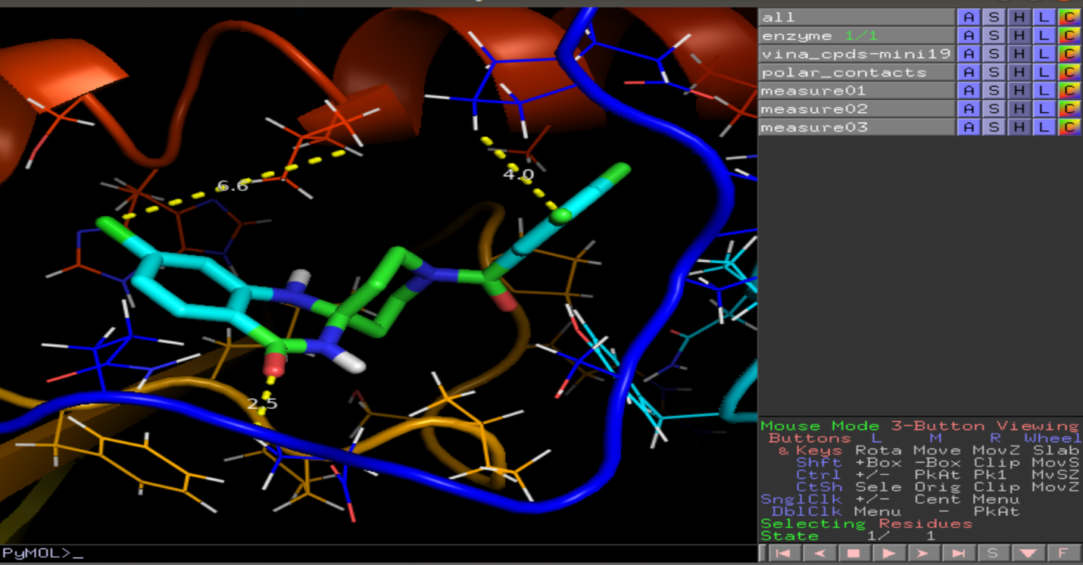

* **Overview :**

1. ***Docking Script Execution:***
   * Running the docking script 🡪 performing docking simulations & exploring various ligand conformations within the defined grid box.
   * Allow the script to generate output files containing information on modes, affinities & distances for each ligand.
2. ***Log Extraction and CSV File:***
   * Running a log extraction script 🡪 The docking output and create a CSV file containing the information as the ligand affinities and distances.
3. ***Sorting and Selection of Best Hits:***
   * Sorting the ligands based on key parameters 🡪 affinity : to identify the best hits.
   * Selecting the ligands with the most favorable interactions with the target 🡪 indicated by lower affinity values.
4. ***Visualization Using PyMOL:***
   * Loading the selected ligands & the target protein into PyMOL for visualization.
   * Explore the 3D structure of the protein-ligand🡪 highlighting the binding modes and interactions.
5. ***Analysis of Interactions:***
   * Analyzing the distances & types of bonds formed between the ligands and the target protein.

***Phase(4): Functional Implications***

Monkeypox is a rare viral disease that is closely related to smallpox & is commonly found in Central and West African regions. Additionally, brivudine and sorivudine are antiviral medications that belong to a group of drugs called nucleoside analogs. It's important to note that brivudine & sorivudine have shown effectiveness against specific herpes viruses but their effectiveness against monkeypox virus infection has not been thoroughly researched or confirmed & Monkeypox virus is a zoonotic virus 🡪 meaning it primarily affects animals but can also infect humans. It shares some similarities with variola virus (smallpox) including similar symptoms and genetic characteristics.

* Limited or no research & studies have been conducted on the effectiveness of brivudine and sorivudine against monkeypox virus infection.
* It is challenging to draw definite conclusions regarding their potential effectiveness against the monkeypox virus.